CONFERENCE MCQT’10
28TH JUNE- 1ST JULY 2010
TOLEDO

HOTEL RESERVATION FORM
Please, complete this form and send it to the hotel you have chosen by 26th April 2010.

HOTEL PINTOR EL GRECO***
C/ Alamillos del Transito, 13. 45002 Toledo
Phone: +34 925285191. Fax: +34 925215819. E-Mail: info@hotelpintorelgreco.com

Double Room Single Occupancy ………………….…..64,49€ + 7% Taxes

Double Room…………………………………………..72.90€ + 7% Taxes
Breakfast is included in the rate.
Price per night.

HOTEL CASONA DE LA REYNA***
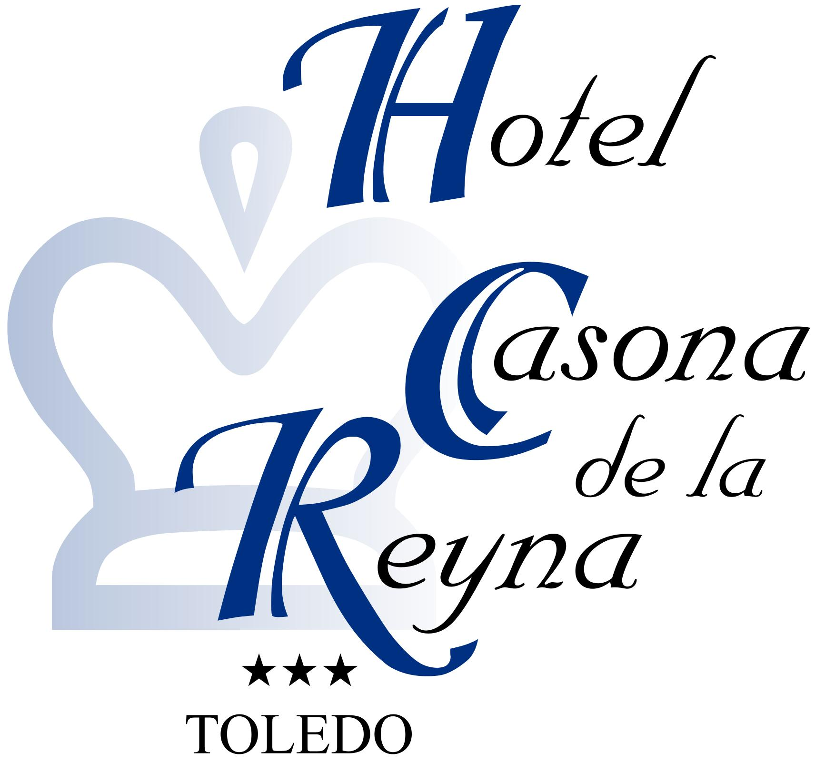
Carreras de San Sebastian, 26. 45002 Toledo
Phone: +34 925282052. Fax: +34 282129. E-Mail: info@casonadelareyna.com

Double Room Single Occupancy ………………….…..64,49€ + 7% Taxes

Double Room…………………………………………..72.90€ + 7% Taxes
Breakfast is included in the rate.
Price per night.

HOTEL SAN JUAN DE LOS REYES***
C/ Reyes Catolicos, 5. 45002 Toledo
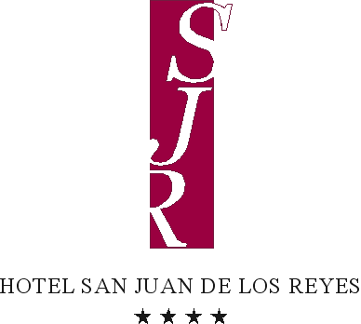
Phone: +34 925283535. Fax: +34 925221410. E-Mail: info@hotelsanjuandelosreyes.com

Double Room Single Occupancy ……………………..85€ + 7% Taxes

Double Room…………………………………………..96€ + 7% Taxes
Breakfast is included in the rate.
Price per night.

PERSONAL DETAILS:

Name: …………………………………………………...………………………………………………
Arrival Date: …………………… Departure Date: ……….………….
Telephone: ……………………………. Fax: ………………………………………….………....
E-Mail: …………………………………………………………………………………………………..
Credit Card Details: ………………………………………………………………
Expiry Date: ………………………………………………………………………
TERM OF CONDITIONS:

- The reservation will be made directly at the hotel completing this form.
- The reservation must be confirmed by the hotel.
- The deadline date for reservations is April 27th 2010. After this date all reservations will be subject to availability.
- The guest will pay directly at the hotel.
- Reservations can be cancelled free of charge up to 72 hours before the arrival date.
- Penalty of 100% for cancellations made after 72 hours before arrival.
- You must provide your credit card number as a guarantee of your booking.

