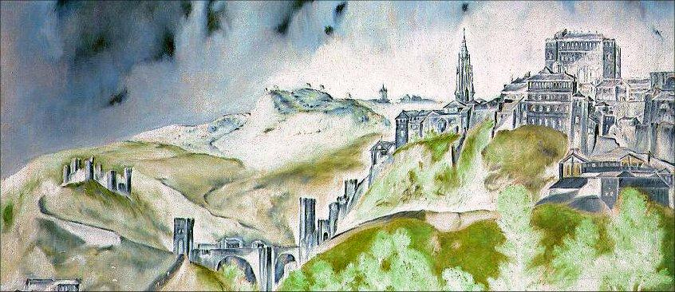

Nonlinear Models in Partial Differential Equations
An international congress on occasion of Jesús Ildefonso Díaz's 60th birthday

June, 14th – 17th 2010

Please tick appropriate: Visa Mastercard

Name of the Card Holder:

Passport Number or National ID Card:

Card Number (16 digits):

Espiry date (month/year):

Amount:

Address:

Zip code/City/Country:

Telephone:

E-mail:

Date:

Card Holder’s Signature:

Send this form as an attachment to: homagejidiaz60@gmail.com

